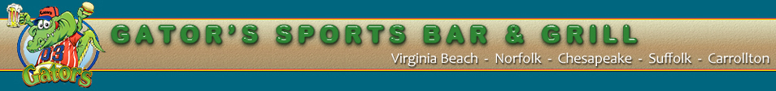
For Immediate Release
Media Contacts:
Bill Hughes David Weber
Manager Publicist
757-435-7066 703-919-8388
HarrisonburgGators@yahoo.com weberda@dukes.jmu.edu

News Release

AJ GATORS OF HARRISONBURG NOW OPEN

Harrisonburg, VA. September 23, 2010 – Looking for a new place to watch the game with your friends? Come to AJ Gators Sports Bar and Grill. Gators is a fun place for college students looking for a new bar to patronize. Gators opened in the summer of 2010, just in time for the school year. With good food and TVs all around, you can catch up on the games going on around the country. Gators is the place for you!
Gators boasts of good food, interactive games and, of course, football. It’s football season, and Gators is all over it. Inside Gators is college football heaven, with every big team represented in the decor. Of course the JMU Duke Dog is most prevalent, displayed on every table and bar. Just a short walk from campus and from many apartment complexes, Gators is located in the Food Lion Shopping Center on Port Republic road.
With the Game Network, Gators will broadcast any and all of your favorite teams’ games. In addition to football, Gators has touch poker stations, a golf simulation game and a touch jukebox, so you can pick your favorite music to play.
(more)
Gators also has good food for your enjoyment. From seafood to old-fashioned bar food, there’s something for everyone to enjoy. Specials, such as “all-you-can-eat” shrimp on Monday and “all-you-can-eat” wings on Tuesday, keep Gators an inexpensive and fun place to visit. You can even join the Gators rewards club for additional savings!
So come down to Gators; watch your favorite teams play; enjoy the food and have fun!
-###-
About AJ Gators
AJ Gators is owned by Jeff Scharer and Al Zuhars. The privately owned restaurant chain started 12 years ago in Hampton Roads, Va, and has since expanded to include locations all over Virginia. Our local AJ Gators opened for business on Aug. 15, 2010 of this year and is ready for patrons of all ages.

