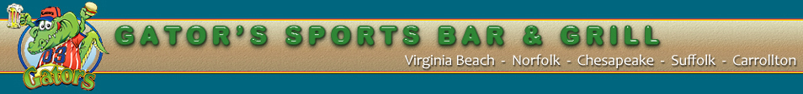
For Immediate Release
Media Contacts:
Bill Hughes David Weber
Manager Publicist
757-435-7066 703-919-8388
HarrisonburgGators@yahoo.com weberda@dukes.jmu.edu

Radio News Release

SUPPORT THE SPORTS SUPERKIDS PROGRAM: 30 SECONDS
LIKE FOOTBALL? LIKE TO HELP KIDS? DONATE MONEY TO THE SPORTS SUPERKIDS PROGRAM IN HARRISONBURG, VA. SPONSORED BY YOUR LOCAL A-J GATORS SPORTS BAR AND GRILL, THE SPORTS SUPERKIDS PROGRAM IS DEDICATED TO TAKING SERIOUSLY AND TERMINALLY ILL CHILDREN AND THEIR FAMILIES TO PROFESSIONAL SPORTING EVENTS, SUCH AS WASHINGTON REDSKINS GAMES. SINCE 1992 THE PROGRAM HAS BEEN HELPING YOUNG SICK CHILDREN SEE THEIR FAVORITE SPORTS TEAMS IN PERSON. KIDS EVEN GET A CHANCE TO MEET THE PLAYERS AFTER THE GAME. FOR MORE INFORMATION ON HOW TO SUPPORT THIS WORTHY CAUSE, CALL BOB LANE AT 757-581-7209.
###
About AJ Gators

Sports Superkids is sponsored by AJ Gators Sports Bar and Grill. AJ Gators is owned by Jeff Scharer and Al Zuhars. AJ Gators started 12 years ago with the first location opening in Hampton Roads, Va, and soon expanded to include locations all over Virginia including your local Harrisonburg restaurant.

